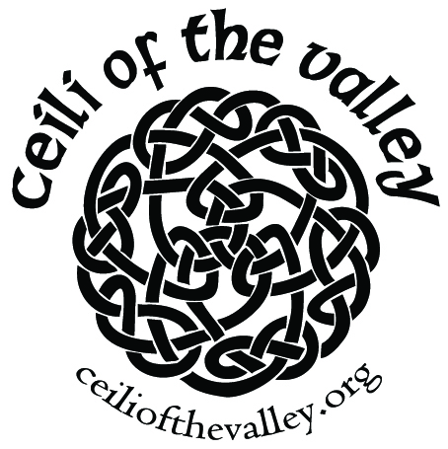

MEMBERSHIP APPLICATION

Please print clearly.
Name: ____________________________________________________
Address: __________________________________________________
City/State/Zip: _____________________________________________
E-Mail: ___________________________________________________
Phone: ___________________________________________________
Date of Birth (DOB) ___________________________ (month & day) - optional
Dues (Jan-Dec): Adult: $10 Family: $20 (children under 18 yrs)
Payment Type: Cash Check (make checks payable to CVS)
NEW MEMBER RENEWING MEMBER
If family membership, please list family members & DOB (optional) here:

____________________________ _______________________________
____________________________ _______________________________
Formed in 2006, the Ceili of the Valley Society (CVS) is a non-profit organization dedicated to promoting and celebrating Irish heritage and culture in the Willamette Valley, primarily through social events that incorporate music and dance. CVS is an Oregon Cultural Trust participating non-profit.
CVS hosts Tuesday evening dance classes & sponsors the Second Friday Ceili - traditional live music and dance event for all ages, held the second Friday of each month.

Membership in CVS provides you with a discount on admission fees for these events and helps support Irish culture. Let us know if you would like to volunteer.

You may bring your completed application and dues to a Tuesday class or 2nd Friday Ceili or
mail to Ceili of the Valley Society, PO Box 221, Salem OR 97308.

We appreciate your support.
Visit us on the web at www.ceiliofthevalley.org or on Facebook
For Office Use Only: Received by: ______________Date: ___________Amt: ________

